West Sam Houston National Forest T Tour
Sunday April 15th, 2018 (Weather permitting)
This is a scenic drive through the western half of Sam Houston National Forest. The proposed route (subject to change) is 66 miles rolling through the east Texas piney woods with several nice views of Lake Conroe. The route starts and ends at the Chevron/Burger King on the southbound I45 junction with Possum Walk Rd (FM 1374). Please arrive by 10:00 for 11:00 departure. There is ample space for trailers and parking. Lunch is about half way through the drive at The Old Montgomery Steak House in the quaint town of Montgomery with lots of antique stores and old town charm. Drive should conclude around 3:00.

Directions to parking: (6505d FM1374, New Waverly, TX 77358) - Take I45 North to New Waverly (exit 102). Cross 1375 and continue north on the feeder road for about 1 mile then turn left (west) on FM 1374. You will see the Chevron and Burger King – parking area is in the rear. Please arrive by 10:00 Am – we depart at 11:00 Am sharp. Since this is a short tour we will not have a vulcher wagon. However, since cell service can be spotty, I hope someone will volunteer to act as a chase vehicle to follow the cars in the event of a breakdown. There are very few lights along the route so we should be able to stay pretty much together.
Please advise Peter Adey 832-702-9085 if you intend to join and the number in your party. Headcount may be needed for lunch reservations.
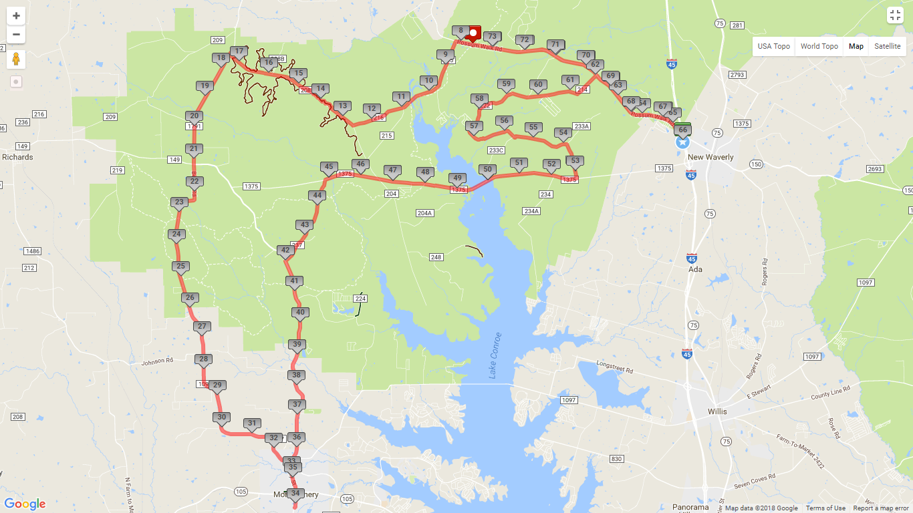

Itinerary:
10:00 – Arrive at Chevron (6505d FM1374, New Waverly, TX 77358)
11:00 – Depart – West on Possum Walk Rd (FM1374) for 8 mi.
Left (south) on FM 215 for 3 mi.
Right at fork on 216 for 2.5 mi.
Right on 208 for 5 mi.
Left on 1791 / Bethel Rd. / 1097 for 18 mi.
Right on 149 for 1 mi.
12:00 – Arrive Montgomery
Lunch: Old Montgomery Steakhouse
204 McCown St, Montgomery, TX 77356
– Antique shopping and town tour
2:00 – Back on the road
North on 149 for 7 mi.
Right on 237 (Osborne Rd.) for 3 mi.
Right on 1375 for 7.5 mi. (bridge over Lake Conroe)
Left on 233 for 3 mi.
Right on 222/214 for 5 mi.
Right on 1374 (Possum Walk Rd.) for 4 mi. to Chevron Station
3:00 – End Tour – Pack up and head home.

