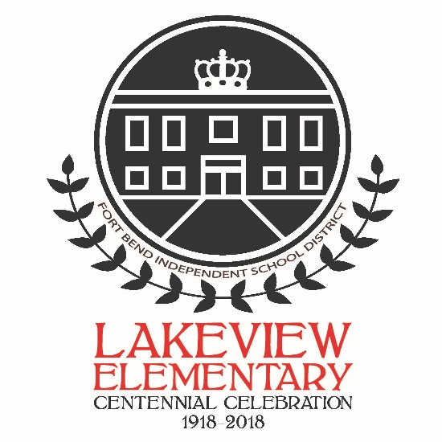
LAKEVIEW ELEMENTARY CENTENNIAL CELEBRATION
Saturday, March 24th, 2018
10:00 am – 2:00 pm

Lakeview Elementary is excited to be celebrating 100 years of growing successful Vikings!

Save the Date! The Lakeview community will be celebrating this historic milestone on Saturday, March 24th from 10:00am – 2:00pm.
Festivities will include a mini historical museum, carnival games and activities, bounce houses, food trucks/booths, vendor marketplace, silent auction/raffle, vintage car show, and some great entertainment. We are also happy to include special appearances by Sugar Land Mayor Joe Zimmerman and FBISD Superintendent Charles Dupre.
The PTA is seeking donations from many sources. If your business or workplace would like to be included as a community partner for our school and this celebration, there are Centennial Celebration Sponsorship opportunities available including corporate cash sponsorships and in-kind donations.
We are actively seeking vendors for this event to include food trucks/food booths as well as Marketplace booths and goods for sale. If you would like to participate by reserving a booth for your business, we are giving our Lakeview family priority treatment!
Entertainment will be provided throughout the event, and openings exist for additional acts. If you or someone you know has a talent itching to be on display, we would like to showcase our Lakeview family to the community.
Silent Auction/Raffle items are needed as well. Donations of services, products or gift cards are welcome. In addition, each grade level/class will be collecting specific items for baskets to be included in the silent auction and raffle, so watch for more information from your student’s teachers regarding those items.
If you or your business/workplace would like to be involved in this event please contact our Centennial Celebration Event Coordinators at lvesponsors@yahoo.com or through our Lakeview Centennial Celebration Event page on Facebook.

A celebration like this only happens once a century!
Be sure to save the date because you won’t want to miss it!

